I got to thinking about how to “save” good snippets of language used in the Screening e-mails I send and vaguely remembered a new feature that Word 2007 has and went hunting for it in Outlook too. It’s called Quick Parts. How it works:

1. Write something really cool that you know you’ll use over and over again
2. Highlight it
3. Go to the Insert tab and look for the Quick Parts drop down
4. 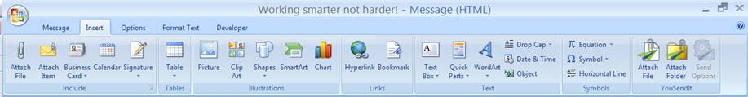Add the item to the Gallery with a name of your choosing
5. Next time you need to tell someone the same thing such as “you are missing blah blah blah”  you can simply insert the pre-written language that explains it in detail

No more wasting time typing it over and over again for common things! Thought this might help us work smarter not harder! Pass it on if you know of someone else it can help!

